Computer Science 1 Lab:
Radon Transform and Image Reconstruction
Hamid Dehghani, School of Computer Science
In this lab, you will use a standard model (phantom) to calculate the Radon Transform (projection data) as well as Inverse Radon Transform to reconstruct images using the projection data. You will investigate the effect of (a) number of projections, (b) Noise in data.

Your reports should be submitted in exactly 1 week (i.e. 11th November 2009), at 5 pm, to emailed as a PDF file to h.dehghani@cs.bham.ac.uk, subject line “CS1 Radon Exercise”

Background: The Phantom. The Shepp-Logan phantom was created as a standard for computerized tomography (CT) image reconstruction simulations of the head and is shown in Figure 1. The phantom image illustrates many qualities that are found in real-world tomographic imaging of human heads. The bright elliptical shell along the exterior is analogous to a skull and the ellipses inside are analogous to brain features or tumours. This phantom is available with MATLAB and can be loaded as any specified sized image. Type help phantom for more information. You will use this phantom, calculate the Radon Transform using radon in MATLAB for a specified number of angles, and look at the effect of limited measurements for image reconstruction.
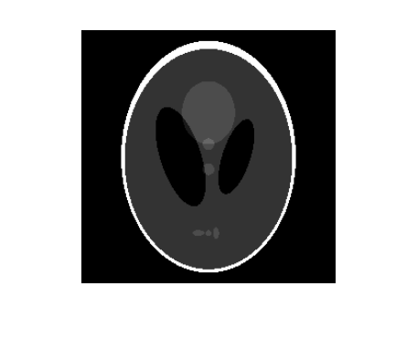
Figure 1. The Shepp-Logan phantom.

Exercise
- Start MATLAB
- Create Head Phantom
Load the phantom into array P with a resolution of 256x256
P = phantom(256);
Displays the image
imshow(P);

- Parallel Beam - Calculate Synthetic Projections
Calculate synthetic projections using parallel-beam geometry and vary the number of projection angles. For each of these calls to the radon function, the output is a matrix in which each column is the Radon transform for one of the angles in the corresponding theta.

theta1 = 0:10:179; %for angles at every 10 degrees from 0 to 179 degrees
[R1,xp] = radon(P,theta1); %Calculate Projection data

Repeat the above and calculate R2 and R3 for angles separations of 5 degrees and 2 degrees.

Question 1: Why do we not go from 0 degrees to 360 degrees?

Note that for each angle, the projection is computed at N points along the x’-axis, where N is a constant that depends on the diagonal distance of the image such that every pixel will be projected for all possible projection angles.
Display the projection data R1, R2 and R3. For example:

figure, imagesc(theta1,xp,R1)
colormap(hot);
colorbar;
xlabel('Parallel Rotation Angle - \theta (degrees)');
ylabel('Parallel Sensor Position - x\prime (pixels)');

Some of the features of the original phantom image are visible in the image. The first column of corresponds to a projection at 0 degrees, which is integrating in the vertical direction. The centremost column corresponds to a projection at 90 degrees, which is integrating in the horizontal directions. The projection at 90 degrees has a wider profile than the projection at 0 degrees due to the large vertical semi-axis of the outermost ellipse of the phantom.

Question 2: These images are called sinograms. How do the sonograms change as number of angles are increased?

- Reconstruct Images using Inverse Radon
To reconstruct images from these calculated synthetic data, we can use the Inverse Radon Transform. For example in case of R1:

Constrain the output size of each reconstruction to be the same as the size of the original image.
output_size = max(size(P));
I1 = iradon(R1,theta1,output_size);
figure, imshow(I1)

Repeat the same for R2 and R3.

Question 3: Comment on image quality and discuss the effect of increasing angular resolution on image quality. Calculate the total image rms error between original image and reconstructed image for each case and discuss your results.

- Effect of noise on projection data
Using R3 data only, add randomly distributed noise of different arbitrary magnitudes of 0.05, 0.1, 0.2 and 0.5. This can be achieved using (example of 0.05 noise):

R3_n1 = R3.*(1+0.05*randn(size(R3)));

Question 4: Reconstruct images from noise added data and discuss effects. You may wish to calculate rms error for these and compare/discuss your findings.

Type: help iradon

Question 5: Are there any built-in functions in iradon that can deal with noisy data? If so, present and discuss the use of these.

